**Aim:** Program to establish Client- Server Connection using Socket Programming with java.

**Code**

**MyServer.java**

import java.net.*;

import java.io.*;

class MyServer{

public static void main(String args[]){

try{

ServerSocket sk = new ServerSocket(4300); // port number

System.out.println("Server has started and waiting for client request...");

Socket s = sk.accept();

System.out.println(s);

DataInputStream di = new DataInputStream(s.getInputStream());

String msg = (String)di.readUTF();

System.out.println(msg);

di.close();

}catch(Exception e)

{

System.out.println(e);

}

}

}

**MyClient.java**

import java.net.*;

import java.io.*;

class MyClient{

public static void main(String args[]){

try{

Socket s = new Socket("localhost",4300);

System.out.println(s);

DataOutputStream dos = new DataOutputStream(s.getOutputStream());

dos.writeUTF("Hello Server How are you?...");

dos.close();

}catch(Exception e){

System.out.println("Exception has occured!"+e);

}

}

}

**Output: -**

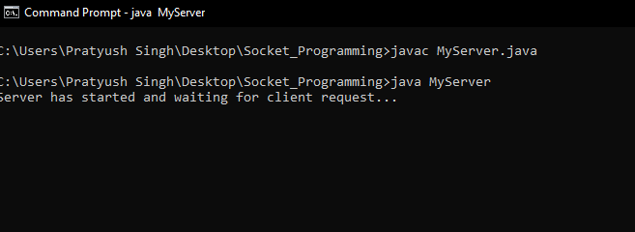

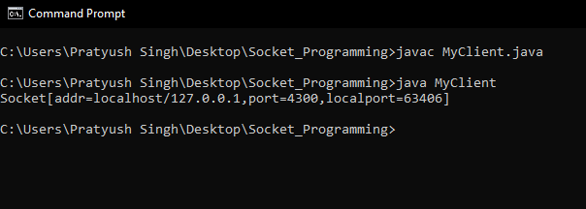

This below message will automatically run just after the call to server.

